How leveling works:

- Player and Allies each have their own Level
- Exp needed to level up increase with level
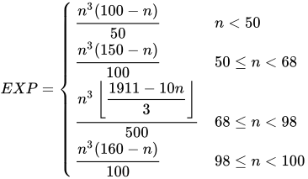
- Exp dropped by enemy is also determined by function (Parameters: Level, Type [Boss, Elite, Normal], Base Factor λ, Trinkets, Random Events

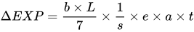.

b = Base Factor
L = Level
s = 1
e = Trinket factor, else 1
a = Special room factor, else 1
t = Type factor (Boss = 3, Elite = 2, Normal = 1)

- Exp value is applied to each team member equally (Might be adjusted later)

- Multiple enemy battles yield a sum of Experience from each enemy

- Average amount of battles for “normal” map: ~12

- Team should reach around level 35-45 after finishing the “normal” campaign (3 Worlds)

- Potentially offer alternative ways to level a creature (Monster vendor, Special events…)

How stats work:

- Each creature has a “growth factor” for each stat which is added per leveling

Example: Meanion has Intelligence of 3 → Level 40 Meanion = 3 * 40 = 120 Intelligence

- Exception: Add something like +10 to HP always

- Player also has growth factors, those can be determined in the beginning
- Player is strong than early monsters, gap closes with later monsters

How skills work:

- Each creature has at least 1 base skill (From level 1)

- Each creatures has a set level of skills learned on specific levels

- Skills are inheritable from Fusion (Not boundless)

- Max 8 Skills per Entity (Need to forget old skills)

- Stronger skills tied to higher levels

